Jacob Ciurca

Dr. Lu

Lab 7

Cosc 320

10/25/2020

**Pre Lab:** Reviewed what we learned about hash tables and functions. Also reviewed given source code and understood each function within the code.

**Lab:**

**Lab_07.cpp**

#include <iostream>

#include <fstream>

#include "d_except.h"

#include "d_hash.h"

#include "d_hashf.h"

//extract a word from fin

ifstream& getWord(ifstream& fin, string& w)

{

char c;

w = ""; // clear the string of characters

while (fin.get(c) && !isalpha(c))

; // do nothing. just ignore c

// return on end-of-file

if (fin.eof())

return fin;

// record first letter of the word

w += tolower(c);

// collect letters and digits

while (fin.get(c) && (isalpha(c) || isdigit(c)))

w += tolower(c);

return fin;

}

using namespace std;

int main()

{

ifstream s;

s.open("dict.dat");

string strin;

myhash <string, hFstring> h(1373);

while(getline(s, strin)){

h.insert(strin);

}

s.close();

cout << "Please enter the file name to spell check\n";

string fname;

cin >> fname;

s.open(fname);

string w;

while(!s.eof()){

getWord(s, w);

cout << "Misspelled words: \n";

if(h.find(w) == h.end()){

cout << w << endl;

}

}

s.close();

return 0;

}

**Sample.txt:**

somtimes I make a lot of

mistaks whn i typee

becaus i typ too fast

**Sample Outputs:**

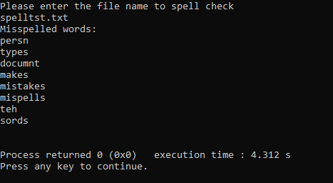 comparing output to given reference

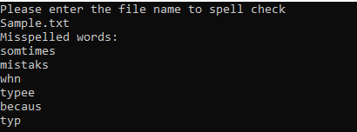 Output for new file I created

**Post Lab:** This lab was good at showing us how to implement a hash table and that there are many ways you can you a hash table. This lab took me about 1 hour 45 minutes to complete and I completed this lab by myself with no help.